**Employee Appreciation Based On Customer Satisfaction Using IBM Cognitive Services**

# INTRODUCTION

### OVERVIEW

Employee satisfaction is a measure of how happy workers are with their job and working environment. Keeping morale high among workers can be tremendous benefit to any company because happy workers are more likely to produce more, take fewer days off and stay loyal to the company. There are many factors in improving or maintaining high employee satisfaction. But before that, it is important to measure the satisfaction levels of the employees. Hence, this project aims at measuring Employee Satisfaction and its impact on employee retention .The project’s conclusion includes the final questionnaire which can be used for the annual employee satisfaction survey in the company and an explanation of all the parameters used with their respective reasons. Recommendations which were drawn from the study and limitations of the research have been provided at the end the way you treat your employees is the way they treat your customers According to a recent article, creating an employee recognition culture can increase employee retention by up to 31%. Employee recognition is the process of showing appreciation for an employee’s achievements, actions, and contributions. In big companies (Amazon/Swiggy/Uber ) appreciation is given to the employees based on the customer feedback or satisfaction (chat process/ voice process). Analyzing all the feedback of each customer towards an employee work manually is a tedious job. The main objective of this guided project is to appreciate the employee work based on analysis of customer feedback. We are designing an application where the HR/ user can upload the feedback report of all the employees. The analysis of each employee report is displayed on the Web application in the form of Bar charts.

# 1.2 PURPOSE

In this project, we make use of IBM Cloud Application, IBM Cloud, Tone Analyzer, Node- RED Research in employee Appreciation based on customer satisfaction uses some of the IBM cloudant services. Depending upon the data attributes and size. , which occur due to a change or decrease of the business reduce employee morale and make it difficult to hire for other positions. When employee leave by choice, The company can decrease the costs while moving forward with other hiring decisions. Customer satisfaction is the important to understand because it can be decrease without incorporating staff departures. As the employee satisfies the customer the company can perform hiring freeze. The company doesn’t replace them.

### 2.LITREATURE SURVEY

### 2.1 EXISTING PROBLEM

### EXISTING PROBLEM APPROACHES OR METHOD TO SOLVE THE PROBLEM

Findings of this study focused on three factors namely Behavioral, organizational, and environmental factors. These factors attempted to find the relation between these factors and employee job satisfaction, and it was found that all the three factors have a positive impact on job satisfaction. The study concluded that organizational factors are the most important aspect for job satisfaction of the employees in a company i.e., if the employees are treated equally and fairly and they are properly supervised, their level of satisfaction can be increased towards their job. The research design used in the research was descriptive. This research was used because it is a good, structured instrument for collection of data. The research method used was survey method. The research technique used was Questionnaire. In all the above research, Researchers have found that for the growth of any organization employee satisfaction is very important. A few factors that were prominent to the employee satisfaction in the research before were income, promotion, feeling of fulfillment, work environment, relations with superior.

### 2.2 PROPOSED SOLUTION

This paper draws attention to the importance of employee satisfaction in the transportation and logistics service industry. For research purposes, Spector’s job satisfaction survey was used, which observes nine facets of job satisfaction, helping us to outline the viable measures that could improve employee satisfaction in the selected company. The research indicates that the employees were satisfied with their supervision, co-workers and the nature of work. Indifference was expressed with respect to payment, rewards, benefits, working conditions and communication. Dissatisfaction was only identified in the field of promotion opportunities. The identified facets that trigger different feelings of satisfaction also explain the possible consequences fort the effectiveness of the selected transportation and logistics service company and the whole industry sector as such. Key words: employee satisfaction, job satisfaction survey.

### 3.THEORITICAL ANALYSIS

A variety of definitions of employee satisfaction can be found; however, they all describe job satisfaction as a result or a form of behavior that an individual brings to the workplace (Weiss 2002, 174; Cooper and Locke 2000, 166; Levi 2006, 288; Smith, Kendall, and Hulin 1969). It is often described as a multidimensional psychological response to one’s job, referring to internal cognitive (perception) and affective (emotional) states accessible by means of verbal or other behavioral and emotional responses (Hulin and Judge 2003, 256; Atefi et al. 2015, 2; Hayes, Douglas, and Bonner 2015, 5). For our research purpose, Spector’s (1997, 2) definition is also relevant. The author identifies job satisfaction as ‘how people feel about their jobs and different facets of their jobs.’ In particular, he stresses the link between negative and positive emotions that affect employees’ behavior and performance, which in turn affect organizational results. Measuring employee satisfaction is particularly relevant from the perspective of company’s performance (Meneghel et al. 2016, 11– 12). Satisfaction increases the sense of belonging to the company (Gil, Llorens, and Torrente 2015, 100), making employees perform.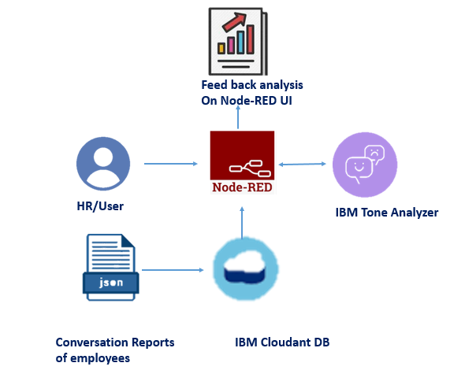

Fig 1: Theoretical Analysis

Companies that do not promote employee satisfaction can on the other hand encounter deviant work behavior manifested as delays, absenteeism, or turnover (Spector 1997, 58; Levi 2006, 301) as well as counterproductive behavior-behavior that damages the company and appears in the form of corruption, sabotage, extortion, theft, fraud, or violence (Levi 2006, 305). Judge and Saari (2004, 399) also point out a possible increase in abuse of alcohol, drugs, and stimulants, along with conflicts and strikes. In addition, employees who experience feelings of dissatisfaction are less prone to invest additional efforts. They tend to avoid voluntary extra work, fail to achieve performance standards, or carry out their work on time, complain about trivial things, don’t want to follow instructions, and quickly accuse others of wrongdoing (Keenan 1996, 6; Špitlar 2009, 34). These behavioral patterns can lead to high long-term costs, causing a lack of personnel, delays, errors, and work-related errors. Different theoreticians examine a variety of job facets which represent stimulus for awakening different emotions, both positive and negative (Judge and Saari 2004, 395–396; Robbins and Judge 2015; Huczynski and Buchanan 2013; Schermerhorn et al. 2012). Since we are applying Spector’s (1997) model, we present the following facets causing job-related (dis)satisfaction: pay, fringe benefits, supervision, contingent rewards, operating procedures, communication, and the nature of work, promotion, and co-workers.

### 3.1 BLOCK DIAGRAM

### See the source image

### Fig 2: Block Diagram

Measuring employee satisfaction is particularly relevant from the perspective of a company’s performance (Meneghel et al. 2016, 11– 12). Satisfaction increases the sense of belonging to the company (Gil, Llorens, and Torrente 2015, 100), making employees perform more conscientiously and with greater commitment (Babalola 2016, 935–937; Pham and Pham 2016, 1445), which enables the company’s further growth, development, and competitiveness (Huang, Huang, and Tzeng 2016). Harter, Schmid, and Hayes (2002, 268) also believe that job satisfaction relates to higher efficiency, productivity, and lower absenteeism. This also affects individuals’ willingness to acquire new skills (Dubey and Gunasekaran 2015), make more small improvement suggestions and innovation propositions, and increase their dedication to long-term company success (Zupan 1999, 5). The importance of ensuring employees engagement level, commitment, and satisfaction with their company.

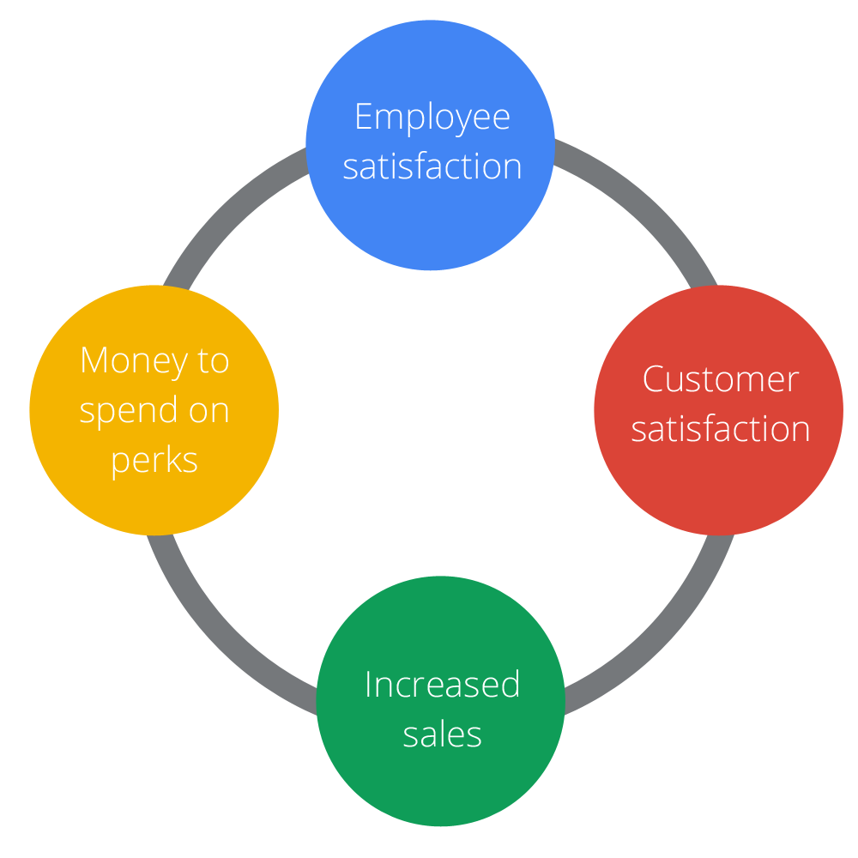

Fig 3: Block Diagram 2

### 3.2 HARDWARE AND SOFTWARE DESIGNING REQUIREMENTS OF THE PROJECT

* He fetches the feedback data of employees from Cloudant Db.
* The fetched data is analyzed by the tone analyzer.
* The analysis of feedbacks  is showcased on UI in the form of graphs.
* To accomplish this, you should complete the following activities.
* User / Hr. interacts with the web page build.
* Create IBM Services.
* Clodant DB
* Tone Analyzer
* Upload Feedback data to Cloudant DB
* Create a Cloudant DB database
* Create Feedbacks
* Build Web Applications
  1. **HOW TO CREATE TONE ANALYSER SERVICE**
* Once you log into your IBM  Account You get redirected to IBM Dashboard
* Navigate to the dashboard and click on the catalog where you will get all the list of services in the IBM cloud.

* Search for Tone analyser in the search bar
* You will get the tone analyser service, double click on that service then you will be redirected to the other page.
* You will be redirected to the below page where you need to give the service name, you will get some service name by default let it be like that and click on create.

### After successfully creating the service, you will get redirected to  the following page, where you will find  different options,  click on Service Credentials from the left pane.

### You will find  credentials like API key, URL etc., which will be used to configure in node-red.

### 4.EXPERIMENTAL INVESTIGATION

### ANALYSIS OR THE INVESTIGATION WHILE WORKING ON THE SOLUTION

1. Now it's time to analyze the feedback documents uploaded to the database. To accomplish the above activity, we create a node-red UI Which looks like the below image User can select the name of the employee and the analysis of the feedbacks of a particular employee is showcased on UI.
2. Let us create a back-end Flow for this your node-RED flow contains the following Nodes
3. Dropdown node - to select the employee.
4. Cloudant DB node - to fetch the created Documents and store the analyzed sentiments.
5. Tone Analyzer - For emotion analysis.
6. line-chart- displays the graphs.
7. Function Nodes: to Parse the incoming messages. Now that you have created all the services, it's time to create the document (contains feedbacks of the customer  for each employee ) to the  Cloudant DB

You need to complete the below tasks to accomplish this activity Create Database Create the documents to Database.

### 5.FLOW CHART

### DIAGRAM SHOWING THE CONTROL FLOW OF THE SOLUTION

Here, the control flow of the solution describes through the customer satisfaction. It is a collection of data. The data of the solution describes the Employee’s Job Level, Job Role, Total Working experience and Accuracy and level of impressing to the customers

### Agent Performance and Customer Satisfaction

### Fig 4: Control Flow of Structure

### Efficiency of the control flow of the solution depends on the employee’s work. Any company is primarily defined its employees, it takes the attrition rate or the employees’ intention of a company is Leaning towards a higher value.

### Employee Recognition: The Key to Customer Satisfaction

### 6.RESULT

### Employee appreciation is paramount for creating a positive work culture and positive customer experiences. The desire to be appreciated is at the core of human nature and according to psychologists, sincere appreciation is one of the best strategies for employee retention and happiness. Employee engagement activities are expensive and require weeks or months of planning. However, employee appreciation and recognition, which pretty much have the same effect on the business, can be started without spending much time, resources, or money.

### 7. ADVANTAGES AND DISADVANTAGES

Feedback from your customers is a crucial aspect of developing a successful business. It allows you to ensure that your products, services, and customer support are all on the right track. Without feedback, your company may be making decisions that go against your customers’ interests and your business would quickly start to suffer.

One of the primary ways to measure customer satisfaction is to use a customer satisfaction survey. These surveys are designed to give you anonymous insight about how the customer views your company and what – if anything – needs to be changed to retain their business. Customer satisfaction surveys are extremely beneficial, but they are not without their weaknesses. Here are some of the pros and cons to using customer satisfaction surveys.

### 8. CONCLUSIONS

### Customer satisfaction is addressed as a strategic business development tool. Customer satisfaction does have a positive effect on an organization's profitability, satisfied customers form the foundation of any successful business as customer satisfaction leads to repeat purchase, brand loyalty, and positive word of mouth. Satisfied customers are most likely to share their experiences with other people to the order of perhaps five or six people. Equally well, dissatisfied customers are more likely to tell another ten people of their unfortunate experience. It is important to realize that many customers will not complain, and this will differ from one industry sector to another. In other words, we often are not aware of the extent of satisfaction / dissatisfaction if we do not ask. Customer satisfaction research should be done with greatest care. Measuring customer satisfaction must be a continuously, consistent, timely, accurate and reliable process.

### 9. APPENDIX

### SOURCE CODE

### click on create document your document will be created

Repeat the above process for the other three employees

### Text for Pradeepthi:

{

  "_id": "Pradeepthi",

  "_rev": "3-bda64a5abad819e876b532946f2ca24d",

  "conv": [

    {

      "text": "Hello, I'm not happy with your product. There was a damage when it was delivered",

      "user": "customer"

    },

    {

      "text": "OK, we have done our part. I am not responsible for this",

      "user": "agent"

    },

    {

      "text": "Well, actually it is having patches and was less attractive",

      "user": "customer"

    },

    {

      "text": "That is up to to decide while purchasing.",

      "user": "agent"

    }

  ]

}

**Text for Rincy :**

{

  "_id": "Rincy",

  "_rev": "2-f3a40a00bafeb328ecb0de87cf8bf07e",

  "conv": [

    {

      "text": "Hello, I'm very happy with your product.",

      "user": "customer"

    },

    {

      "text": "OK, that look good thank you for that.Is it working good?",

      "user": "agent"

    },

    {

      "text": "Well, actually it is working nice:(",

      "user": "customer"

    },

    {

      "text": "Happy to hear from you .Thank you for your feedback.",

      "user": "agent"

    }

  ]

}

**Text for supriya :**

{

  "_id": "Supriya",

  "_rev": "3-f7bbc934296de3735208762e79c453f8",

  "conv": [

    {

      "text": "Hello, I'm not satisfied with your product and delivery",

      "user": "customer"

    },

    {

      "text": "Are u Crazy we will not support for this kind of request",

      "user": "agent"

    },

    {

      "text": "Well, actually it is the worst product no proper finishing and worst quality. Though to raise a complaint against the firm.",

      "user": "customer"

    },

    {

      "text": "ok you can raise complaint but we are not responsible",

      "user": "agent"

    }

  ]

}

Now Your database will contain 4 JSON documents as shown in the below image

### Fig 5: Sentiment Analysis in Data Base

### Fig 6: Output Graph of Sentiment Analysis